Crescent City Steak House - Continuing the Cultural Creativity of New Orleans
Intangible Cultural Heritage of New Orleans is the mainspring of its cultural diversity and its maintenance - a guarantee for continuing creativity.
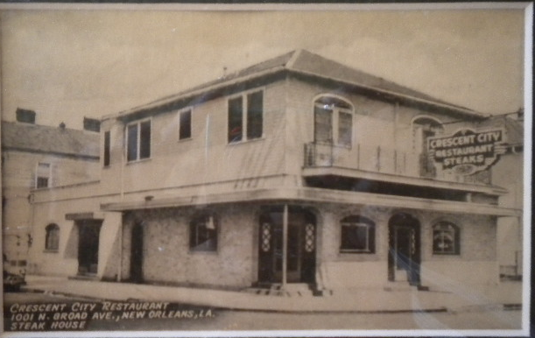 | 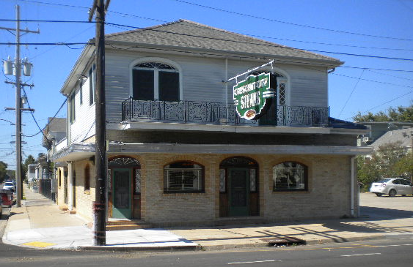
UNESCO has described “The intangible cultural heritage as the practices, representations, expressions, knowledge, skills – as well as the instruments, objects, artifacts and cultural spaces associated therewith – that communities, groups, and in some cases, individuals recognize as part of their cultural heritage…"
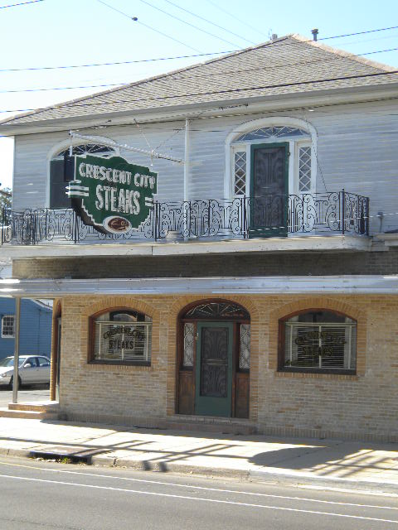 | 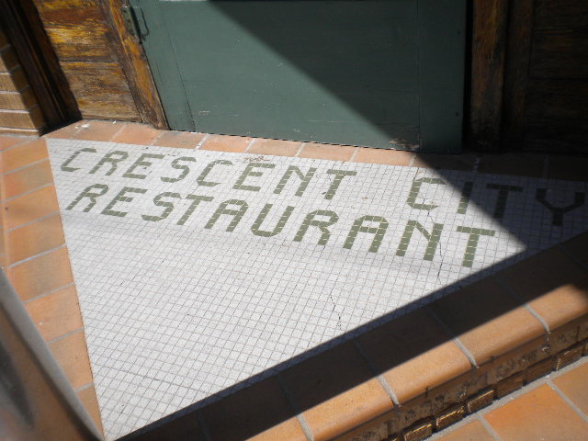 | 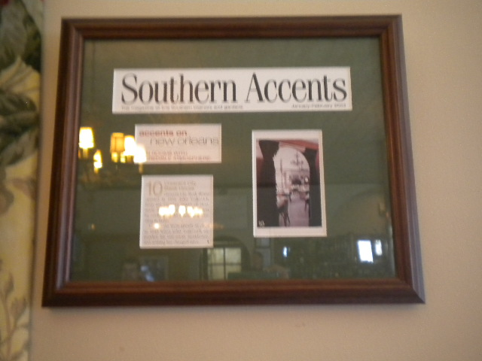 | 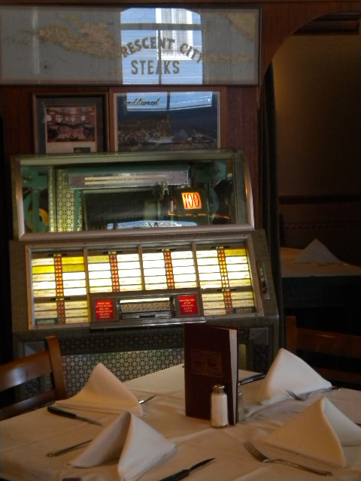
The Crescent city steak house, with its iconic neon sign and familiar storefront, its dominance over the culinary world, and its old world ambience has stood the test of time and become a pillar of fortitude for the neighborhood and embodies the continuation of creative cultural heritage. As owner and collaborator Anthony Vojkovich adds “there is a constant flux, we have survived the 80’s and the 90’s, you have the same issues that come and go- but someone’s got to stay. The neighborhood as such is unique it’s stable and unstable at the same time and we have established ourselves as a fixture in this neighborhood where change is an operative word.”
Collaborative ethnography and research
In the textbook 'The Chicago Guide to Collaborative Ethnography' , Lassiter sums up " collaborative ethnography as an approach to ethnography hat deliberately and explicitly emphasizes collaboration at every point in the ethnographic process." he also emphasizes on the writing of ethnography with local community consultants as active collaborators in the process. The central theme of 'we keep what we have by giving it away' propagated by Lassiter guided our research as we realized the that in understanding what 'Crescent city Steakhouse' stood for namely 'pride' and a 'sustainable local enterprise' we can give back to a community still recovering from the ravages of hurricane Katrina.
As postulated by ethno-science I began building on the 'emic-based' information database (insiders views), be it the old photos that were shared by the family, or the stories that transported me through time and space. The 'etic-based' research(outsiders view) was photo documenting the archive of framed awards, articles and events of New Orleans that trace the tangible history of the Crescent City success story, while the long standing patronage and dedicated staff and customers gave me valuable insights into its stature in the neighborhood and its importance in the community. One of the more moving of 'participant observations' was made by Mrs. Vojkovich that "Everyone was happy when we didn't change anything after the hurricane they won't let us change and thanked us for keeping everything exactly the same as before." She feels honored that it meant so much to everyone and said to her son "you can't disappoint people."
In upholding the perspective of the community participants upmost importance was given to clear preservation of the informants perspective. All documentation produced was shared and feedback collected and incorporated into the work. It was most challenging to capture the 'cultural heritage' that expressed itself not only in food, design, decor and music but also the quality of food, dedication to the craft, authenticity, identity, culture of service, love, neighborliness, pride and fortitude that Crescent city Steakhouse represents. The approach adopted for this study was observational, historical as well as phenomenological. The study tried to recognize how the place grew in not only in its historic value, longstanding acceptance, aesthetic value and neighborhood enhancement but also identifying that the community supports the place and helps perpetuate its survival through several decades. As Mrs. Vodkovich summarized it "I hope for my kids and Grand kids to see the steakhouse stay." The role this establishment has played in the growth and maintenance of the city culture needs to be acknowledged and preserved and this marvelous story needed to be interpreted and told.
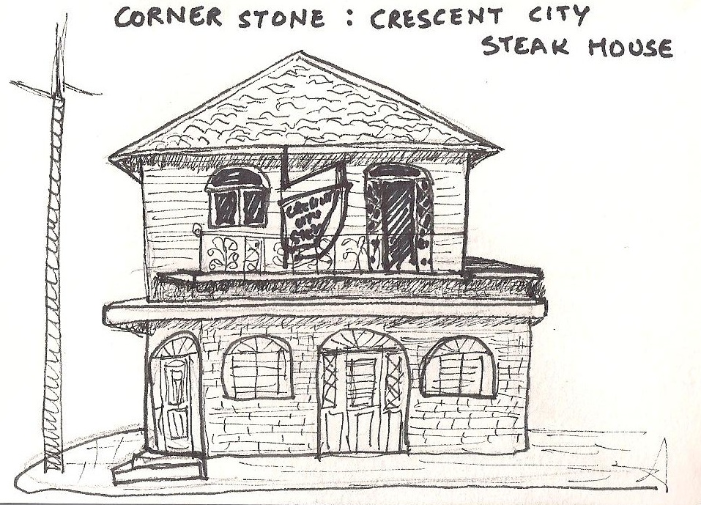 | 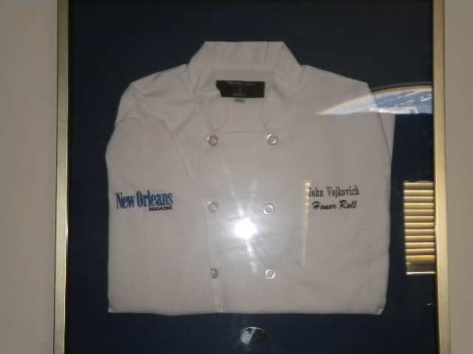
While the site documentation itself was very informative, it was the face-to-face interviewing that was most enjoyable as simply witnessing the emotions flashing across the faces revealed more than half of the story. Mrs. Vojkovich teared-up recalling the harsh times and nostalgia overtook as she recalled John Vojkovich's tales. Her son Anthony Vojkovich was transported to his very first encounter with his wife. Seeing the Community consultants relive their memory and seeing the culture of the place thru their eyes was both fulfilling and intriguing. Interviews conducted were structured yet open-ended allowing for interpretation and personal reflection by the participant.
Since the patrons of the Crescent City Steakhouse enjoy not only their hospitality but also discretion and privacy, a group interview or live capture of the active involvement of its participants could not be documented in photographs or audio recording and I hope someday this beautiful aspect will also be captured.
On a final note, this exercise allowed me to perceive layers and depth to not only, the physical and functional manifestation of the Crescent City Steakhouse but also perceive its historic, cultural and social glory. It proved to be representative of human strength, perseverance, community-building, city pride, resilience and a great family story. The culture and era captured in this time-capsule, speaks of older times, simpler life and human interactions. The easily identifiable and recognizable architecture and decor stand testimony to every human relationship, every life event and generations of New Orleans whose life would be incomplete without a meal at this Cornerstone Neighborhood place.

UNESCO website [http://portal.unesco.org/culture/en/ev.php-URL_ID=34325&URL_DO=DO_TOPIC&URL_SECTION=201.html]
Personal Interview with Anthony Vojkovich on October 22’ 2011
Lassiter E Luke, The Chicago Guide to Collaborative, CHP2: Defining Collaborative Ethnography
Personal Interview with Krasna Vojkovich on November 12’ 2011
Personal Interview with Krasna Vojkovich on November 12’ 2011

